**How to bulk download quiz results in iSpace**

1. **Go to your course and enter to the quiz**
2. **Find the Administration Block, which is usually located at the bottom left side of your page. In Quiz Administration, you will see Results and under this tab, you will see Grades and Responses.**

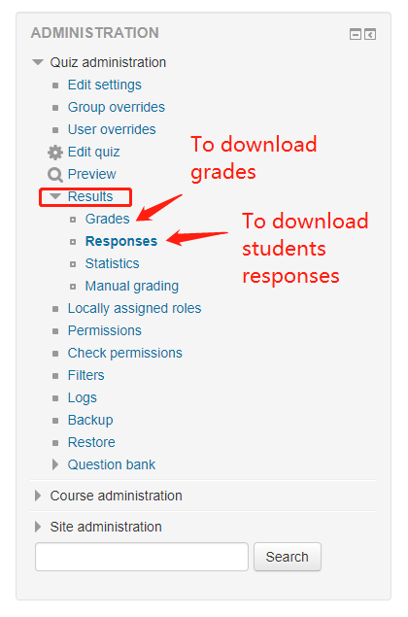

1. **To download student grades, click Grades. Then download student grades with your choice of file type. (.csv or .xlsx are common)**

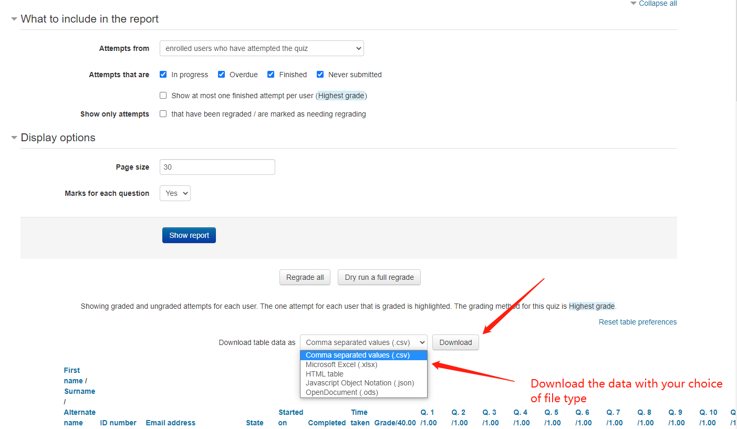

1. **To download student answers, click Responses.**

