**How to bulk download student assignments in iSpace**

1. **Go to the assignment activity that you wish to download student assignments from. Then click View all submissions.**

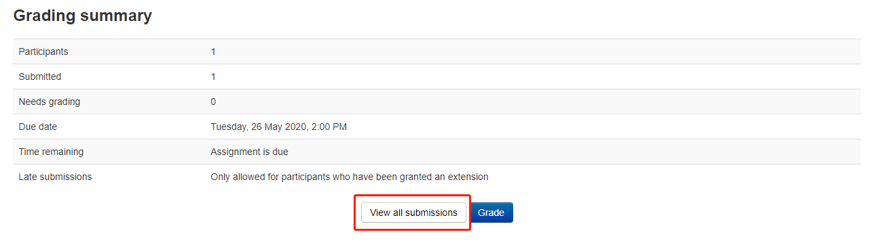

1. **Scroll to the bottom of the page and find the Options setting. If “Download submissions in folders” is not checked, please check this option.**

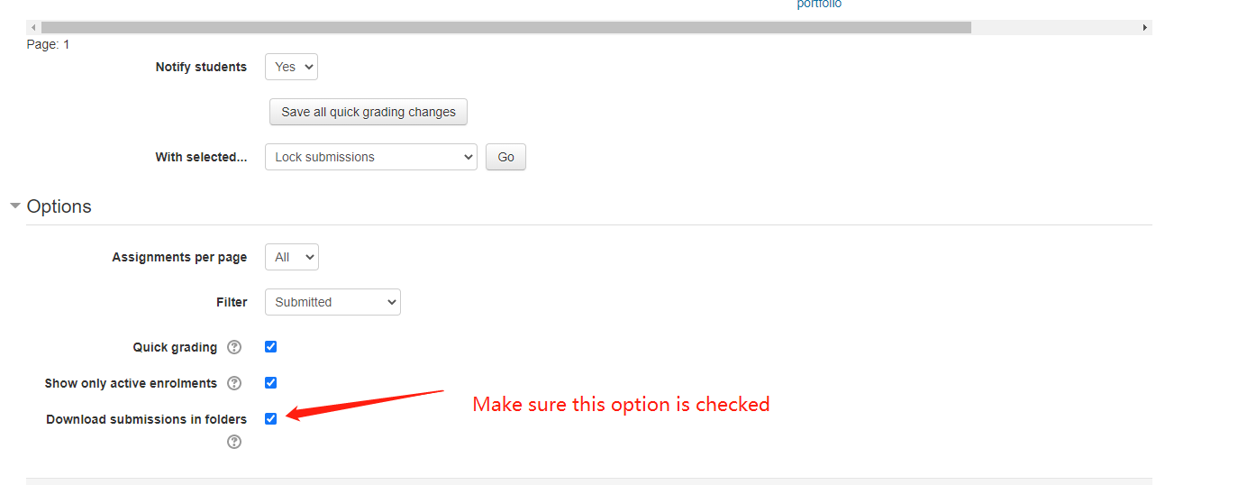

1. **Then scroll back to the top of the page. In Grading action, select Download all submissions.**

